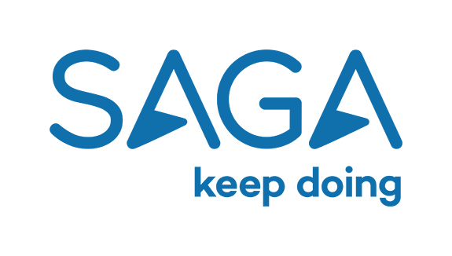
Dimensions:
Reports | 3 direct
Direct Reports:
1 x Product Manager
2 x Purchasing Manager

Approx. 6 indirect reports
Grade: | 4H

Job Title: | Head of Product & Purchasing – Touring
eports to: | Director of Product & Purchasing
Company: | ST&H
Department: | Product & Purchasing
Location: | Enbrook

Job Description Summary
At Saga plc, our people are our business. We recognise that it’s our people that provide a continuously excellent experience to our customers and deliver service that is beyond their expectations. It’s because of that ethos that we focus on developing a great product to bring that to life and to grow our business.

As Head of Product & Purchasing for our Touring products, you will provide end to end leadership with full responsibility for our Touring product lifecycle. The role also leads a team accountable for product development and innovation, contracting, product delivery and operations.

You’ll work closely with your peers across the Product & Purchasing department, as well as the Director of Product & Purchasing, to deliver against our strategic objectives. You’ll champion our brand and our customers and bring the Saga Way to life in everything you do.

Responsibilities
- Reporting to the Director of Product & Purchasing and working as part of the leadership team for the business, focussing on building and delivering against core business objectives and ownership and responsibility for the P&L of Touring;
- Contributing to the Saga Holidays strategy and owning the delivery of relevant programmes or work streams involving the Touring product;
- Drive & deliver the aggressive growth plans for Saga Holidays in line with budget targets by creating an added value proposition for our customers;
- Ownership of all third-party supplier relationships, including our DMC relationships in resort from a Touring perspective;
- Ensure the delivery of high performing, efficient and compliant operations and driving customer service arrangements that deliver excellence and enhance the Saga brand;
- Create a culture within which all fully understand the need for exceptional customer service and inspire full commitment to The Saga Way by making customer experience and operational excellence central to our core DNA;
- Promote and deliver excellent performance management practice, ensuring targets are achieved and services are consistently excellent, encouraging all employees to deliver to their best;
- Creating a culture and environment of improvement, within the constraints of legislation and meeting customer needs and expectations;
- Effective delivery of good risk management, embedding the culture of risk management throughout the Touring team;

Working with all internal and external stakeholders to shape, develop and implement Touring product strategy;
- Formulate strategic product buying plans for Touring, to include ground and transport requirements, ensuring that growth targets are achieved, whilst significantly reducing commitment exposure;
- Closely monitor pricing & yield management of Touring, ensuring passenger sales, profit and growth are achieved in line with business targets;
- Use customer insight and trends, historical learning’s and market information to ensure product is in line with demands/trends and positioned well against competitors;
- Provide commentary and analysis on reporting to the business on the performance of the product area and to provide key management information that will highlight potential issues allowing corrective action to be taken;
- Ensure unrivalled levels of customer service and quality are delivered to our customers and to internal customer, achieving agreed quality scores as defined by the business.

The Individual
Capability, Knowledge and Experience:
- An excellent understanding of the Tour Operating industry from product innovation through to service delivery;
- A proven P&L Owner who drives results and has strong strategic planning skills;
- Able to think strategically and support prioritisation of multiple projects to ensure the right plan is put in place to deliver required business results;
- Experience and understanding of operational rigour, discipline and excellence in a multi-site environment, where margins are tight;
- Demonstrable ability to think commercially, with proven experience in driving performance across a product portfolio to ensure that value is realised;
- A talented senior employee with relevant operations experience, who can lead a diverse team of professionals;
- Creative flair, with an ability to think outside the box and reach appropriate solutions to challenging problems;
- Strong presentation, communication and facilitation skills;
- Ability to work under pressure and to tight deadlines;
- Ability to set and follow clear targets and objectives;
- Demonstrable understanding of and commitment to the Saga Way;
- Self-motivated approach to work and highly organised;
- An excellent understanding and ability to manage people at all levels;
- Stakeholder management experience, with the ability to communicate complex ideas in a simple and effective manner;
- Experience of managing risk across a multi-faceted team;
- Willingness to Travel to our resort destinations as required by the needs of the business;
- Deep understanding of the impact of change on the business and the ability to really understand how to land transformational change well and create platforms for success.

Education & Qualifications:
- Educated to degree level or equivalent;
- MBA level qualification is desirable but not essential.
- Proficiency – both written and verbal – in at least one relevant language would be an advantage (e.g Spanish / Italian)

Personal Characteristics:
- Exceptional communicator and strong interpersonal skills;
- Ability to work under pressure and to deadlines;
- High integrity and able to make things happen;
- Highly operationally focused and commercially astute;
- Able to drive change and high growth quickly;
- Collaborative team player who is resourceful and able to mobilise a team;
- Innovative and solutions orientated, very ‘can do’;
- Strength of conviction and ability to influence and negotiate;
- Courage to challenge and do things differently;
- Customer focussed and passionate about building an exceptional customer service ethos;
- Good judgement and ability to create strong professional relationships at all levels;
- A natural leader with a desire to have a broad impact across the brand;
- Strong personal drive and alignment with The Saga Way;
- Able to rally and inspire a remote workforce;
- Determination and resilient in approach with the ability to ‘find a way’;
- Exceptional planning and organisational skills;
- Able to multi-task and manage multiple projects simultaneously.

The duties listed are not exhaustive. Additional hours of work may be required, as determined by the needs of the business. Managers and staff may be required to undertake additional duties, responsibilities and projects as appropriate.

